**User Guide**

Name Recorder Automation

April 2021

Version 1.0

*ISA-PM-2021-01-13-MTech1-2M-NameRecorder_Automation*

*Team Member: Vincent Ng, Zhou Zhe*

# **Table of Contents**

1. **Table of Contents** 2

2. **System Overview** 3

**3.** **System Installation and Configuration** 4

**System Requirements** 4

**Installation and Configuration** 4

**4.** **Name Recorder Automation Module** 6

**Application Layout** 6

**Optimal Audio File Generation** 7

**5.** **Appendix** 8

# **System Overview**

The Name Recorder Automation is an intelligent software agent product that can automate record, normalize, add and remove silent padding of sound of student names read by voice talent.

The name reader system is used for school graduation ceremonies every year that makes use of pre-recorded student names that are played as the students go up on stage to receive their graduation certificates.

This automation system is an excellent candidate and able to save manpower costs and improve the quality and consistency of the name recordings in graduation ceremony events. The benefits include:

1. Less human errors in post-processing
2. Consistency in both volume and silence padding
3. Manpower savings of 82 man-hours/year

# **System Installation and Configuration**

## **System Requirements**

The Name Reader Automation is required to record talent’s voice for post processing and read it for pronouncing the student’s name. the blow table shows the hardware requirements:

|  |  |  |
| --- | --- | --- |
|  | **Minimum Requirements** | **Recommended Specifications** |
| OS | Windows Vista, 7, 8, 10(32-bit and 64-bit) | Windows 10(32-bit and 64-bit) |
| CPU | Intel Pentium 4 1.3 GHz or AMD Athlon XP 1500+ | Dual-core processor, such as the Intel Pentium D or AMD Athlon 64 X2 |
| RAM | 512 MB or more of RAM | 1 GB or more of RAM |
| HDD | 1 GB or more of HDD | 20 GB or more of HDD |
| Microphone | Workable built-in, USB plug-in, or wireless Bluetooth microphone | |
| Speaker | Workable built-in, USB plug-in, or wireless Bluetooth Speaker | |
| VGA | 800x600 16bit Color | 1024x768 16bit Color |

The Name Recorder Automation is only tested and working on Windows Operation systems, which might work for Mac or Linux. You may need to follow the Windows installation and configuration for other OS environments.

## **Installation and Configuration**

**Python Runtime Environment**

As the Name Reader Automation is developed by Python language with several third-party libraries that requires python to be installed. It requires Python version 3 and later and third-party libraries:

* Python GUI (pysimpleguid)
* Python Audio Recording (sounddevice)
* Python Post-Processing (pydub)

The Python 3 runtime is the software stack responsible for installing the Name Reader Automation code and its dependencies and running it as desired.

**Environment Installation and Configuration**

Step 1 – Install prerequisite ffmpeg audio library for post processing.

You need to download ffmpeg executable library before examining the NRA automation tool.

1. Click the Microsoft icon download button from the download page of ffmpeg website via <https://www.ffmpeg.org/download.html> for windows ffmpeg version.
2. Unzip the downloaded zip file and save it to file path C:\ffmpeg
3. To add ffmpeg bin directory (c:\ffmpeg\bin) to Windows system PATH environment variables as follows:

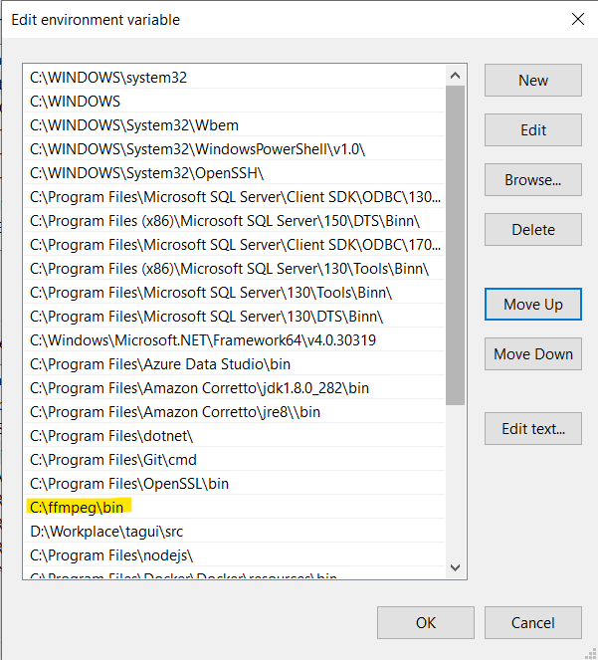

Windows Start Search > Type ‘View Advance System Settings’ > Click ‘Environment Variables’ > Double click Path row under system variable section > Add file path ‘c:\ffmpeg\bin’ to PATH environment variables as above figure.

Step 2 – Install the Python 3+ Binaries from python.org.

You can download the latest Python distribution from the official Python homepage using the following steps:

1. Open a browser window and navigate to the Python.org Downloads page for Windows.
2. Under the “Python Releases for Windows” heading, click the link for the Latest Python 3 Release - Python 3.x.x.
3. Scroll to the bottom and select either Windows x86-64 executable installer for 64-bit or Windows x86 executable installer for 32-bit.

Step 3 – Run the Python Installer

Choose the default settings to do the installation when there is no professional guidance or personal preference. The following items to notice about the dialogs during installation:

1. The default installation path is in the AppData directory of the current Windows user.
2. The Customize installation button can be used to customize the installation location and which additional features get installed, including pip and IDLE.
3. The Add Python 3.x.x to PATH checkbox is unchecked by default. To you check this box if you want Python on PATH where you understand this usage.

Step 4 – Verify Python Runtime Installation

Open Windows Command Prompt window by clicking on Microsoft Logo and R key and typing “run”. In the command line, type python –version and click ENTER button. It should show the version number when the python is installed successfully.

**Microphone and Speaker Verification**

We assume your Windows system has built-in microphone and speaker devices. As now, the following steps are used to test audio device availability:

Step 1 - Right-click the speaker icon on the bottom left of your screen, then select Sounds.

Step 2 - Click the Recording tab.

Step 3 - Try speaking into your microphone to test if it’s working properly. If it is, you should see a green bar rising next to it while you talk.

**Name Recorder Automation Setup**

The Name Recorder Automation is portable application that is not required to be installed. To unzip NameRecorder_Automation.zip locally. You may download it from GitHub at <https://github.com/gvinto/ISA-PM-IPA-2021-01-09-IS02PT-GRP-NameRecorder_Automation/releases/download/v0.1/NameRecorder_Automation.zip>

You will still be required to follow the steps to install and configure ffmpeg (Step 1 of Environment Installation and Configuration). To launch the Name Recorder Automation GUI by double clicking executable file name_recorder_gui.exe.

# **Name Recorder Automation Module**

## **Application Layout**

The following application window shows the Name Recorder Automation system layout:

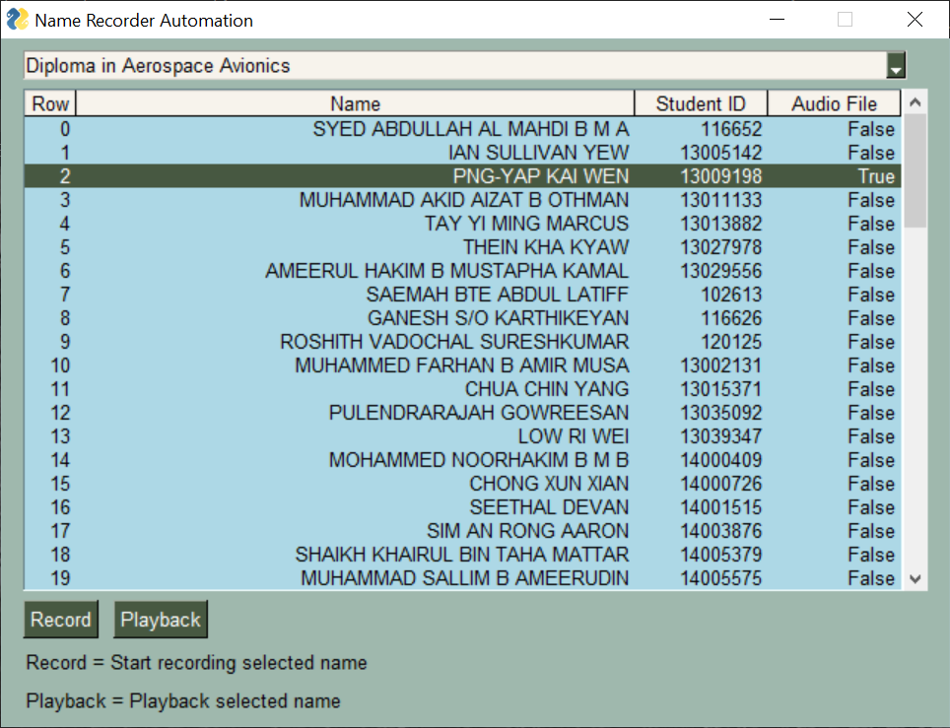

The Name Recorder Automation application consists of below key components:

1. The dropdown list on top of window that allows to select a specific diploma where those students graduate from.
2. Up onto chosen diploma, the full list of student names is populated in the grid that contains different columns such as Row, Name, Student ID and Audio File
3. The Record button at bottom of window that is used when talent to read the name.
4. The Playback button is for playing the selected name.

## **Optimal Audio File Generation**

The talent’s voice file is automatically fetched and processed by serval automation agent such as Noise removal agent, Normalization agent, silence detection agent as well as output agent after talent made the raw audio file.

The output agent saves audio files with alignment where the student’s name (<Student ID>.wav) is selected in Name Recorder Automation GUI.

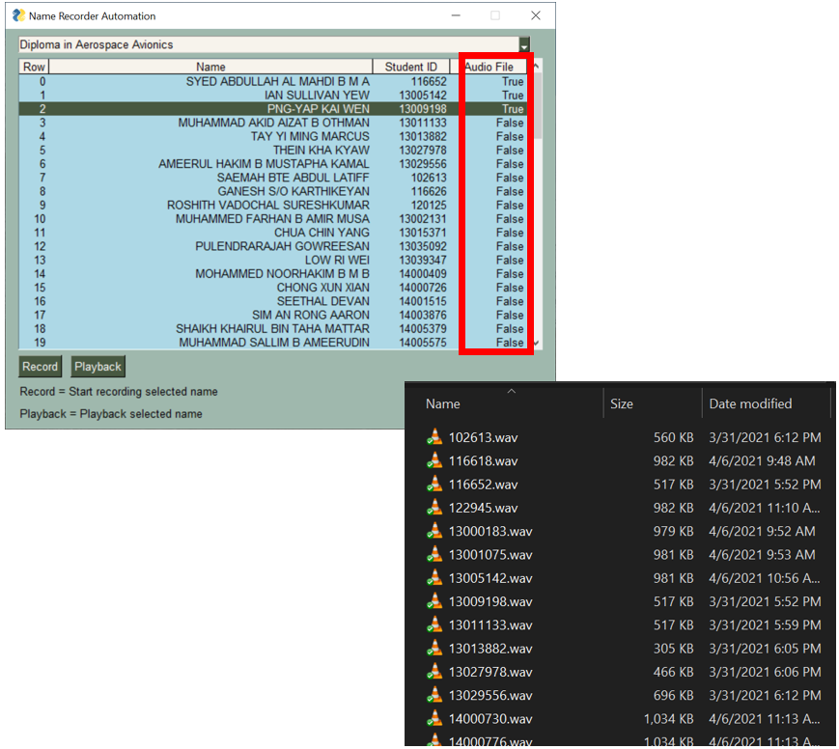

# **Appendix**

For more details of Name Recorder Automation, refer to Appendix folder